LPS Raman Evidence Report
Literature → Powder Raman → DFT Fragment Support → Reference Bands → Future SERS Validation
Prepared for: Sukesh P (M24IM1007) — IIT Jodhpur & AIIMS Jodhpur Joint IDRP
Report date: 30 August 2026
Scope: built entirely from files already present in the project workspace. No measurements, DFT modes, literature values, SERS results, or blank-control results are invented — items not found in the project data are explicitly reported as absent.

1. Objective
To establish a defensible, file-anchored evidence chain for LPS Raman spectroscopy: from published literature, through the project’s own optimized powder Raman measurement, through fragment-based DFT calculations, to a set of DFT-supported reference bands — and to state plainly what is and is not yet established toward LPS SERS detection.

2. Experimental LPS Raman Data
Sample: Lipopolysaccharide from Escherichia coli O111:B4, Sigma-Aldrich L2630 (phenol-extracted, S-type LPS).
Instrument: B&W Tek BWS465-785H / BTC665N-785H-SYS, ~785 nm excitation (784.92 nm actual), 2048-pixel detector.
Acquisition condition used: 60 s integration, 20% laser power, 30 accumulations — the condition documented in the project’s own LPS documentation.docx as the final optimized setting (file: sec-60_power-20_i-30.xlsx).
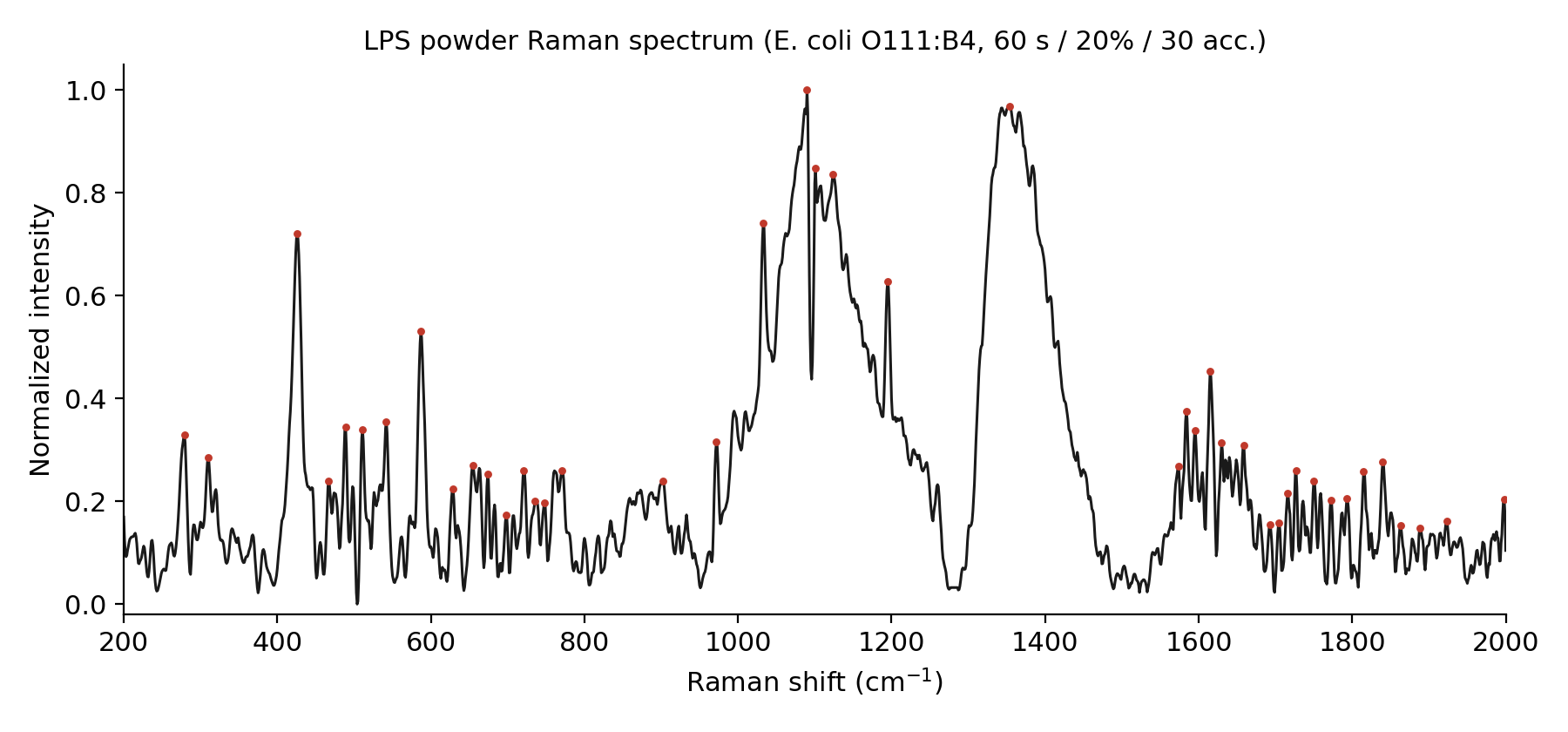
Figure 1. LPS experimental powder Raman spectrum, 200–2000 cm⁻¹, normalized. Red dots mark the 43 major experimental peaks (prominence ≥ 0.08, minimum spacing 10 cm⁻¹).

3. DFT Fragment Model
LPS is not simulated as an intact molecule. Five representative structural fragments — the ones actually present as raw DFT output in the project data — were calculated independently and their spectra pooled:
• KDO (3-Deoxy-D-Manno-Octulosonic Acid) — 84 raw discrete modes
• D-glucosamine — 69 raw discrete modes
• Heptose (L-Glycero-D-Manno-Heptose) — 78 raw discrete modes
• Myristic Acid — 126 raw discrete modes
• Phosphoric Acid — 18 raw discrete modes
Each fragment’s raw Gaussian output (discrete "Peak information (Harmonic)" frequency/activity list) was scaled by the documented factor of 0.9613. This is a fragment-based model, not an intact-LPS quantum calculation — it cannot capture inter-fragment vibrational coupling by construction.

4. Corrected Data-Processing Workflow
The experimental spectrum was reprocessed in this order (correcting a bug found in an earlier audit, where normalizing before windowing had collapsed the signal range):
• 1. Restrict to 200–2000 cm⁻¹.
• 2. Asymmetric Least Squares (ALS) baseline correction.
• 3. Savitzky-Golay smoothing (window 11, polynomial order 3, as documented).
• 4. Min-max normalization — applied only after windowing and baseline correction.
DFT side: discrete modes from all 5 fragments were pooled, restricted to activity ≥ 5% of each fragment’s own maximum, and restricted to 200–2000 cm⁻¹ — 178 candidate modes in total.

5. Experimental–DFT Peak Matching
A one-to-one (Hungarian / linear-sum-assignment) match was made between the 43 major experimental peaks and the 178 DFT candidate modes, with a maximum matching distance of ±15 cm⁻¹ and the constraint that one DFT mode cannot be used to explain more than one experimental peak.
Quantity | Value
Total experimental peaks (prominence ≥ 0.08) | 43
Total DFT candidate modes (5 fragments pooled) | 178
Matched peaks (defensible, ≤ ±15 cm⁻¹) | 26
Unmatched peaks | 17
Matching percentage | 60%
High confidence | 4
Moderate confidence | 20
Low confidence | 2
MAE (matched pairs) | 3.94 cm⁻¹
RMSE (matched pairs) | 5.57 cm⁻¹

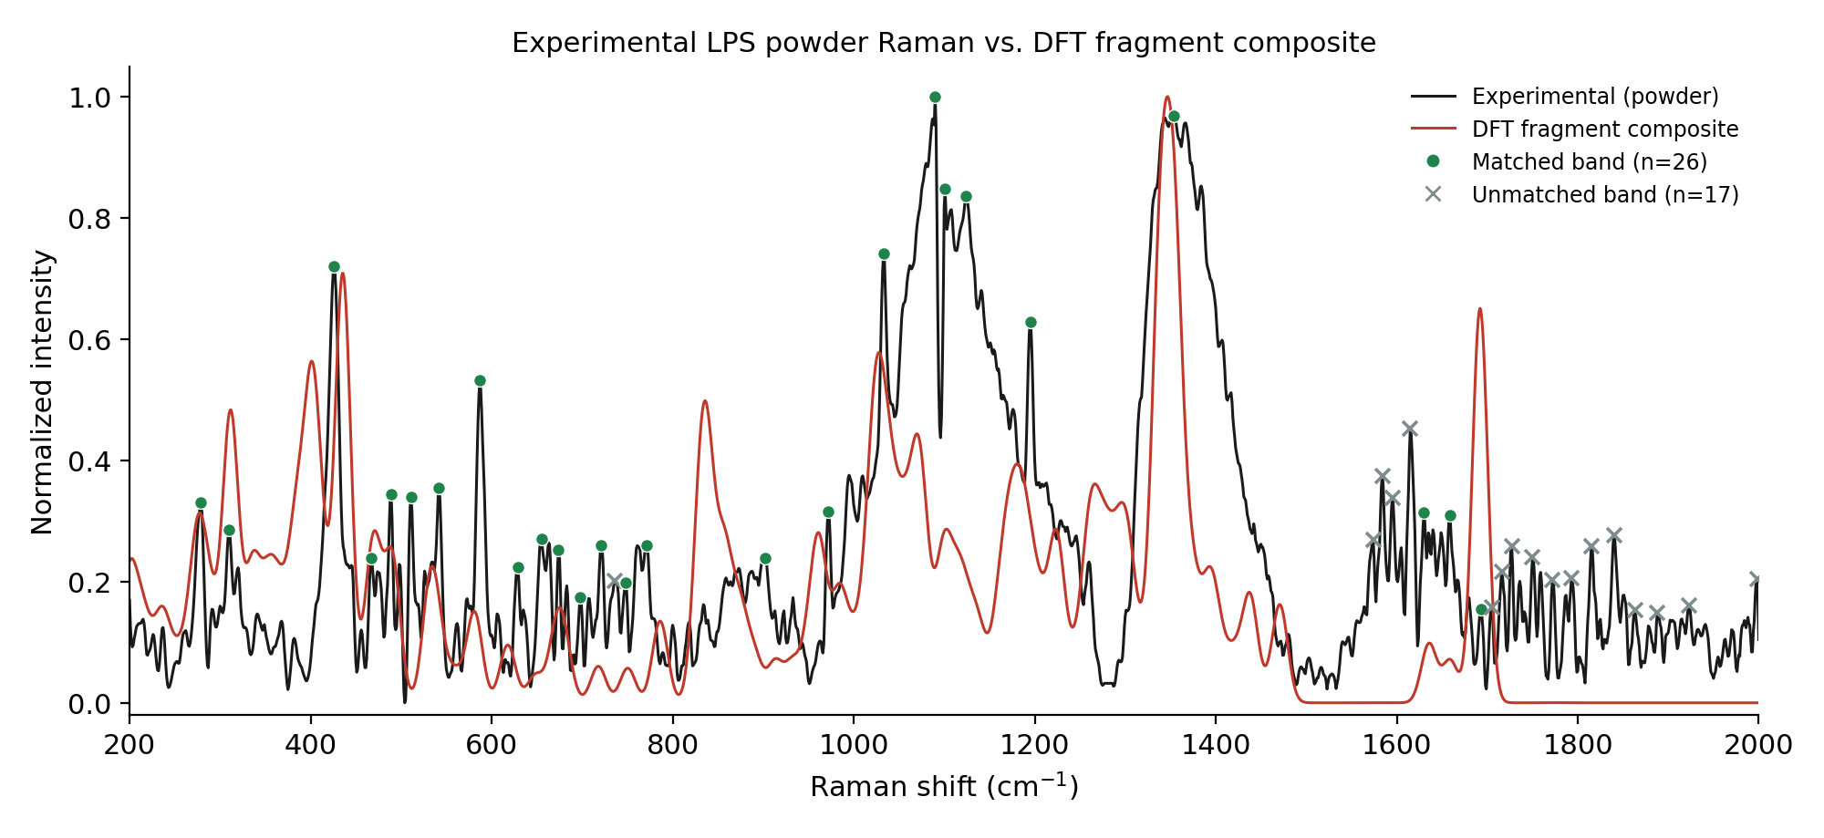
Figure 2. Experimental LPS powder Raman (black) vs. DFT fragment composite (red, NNLS-weighted). Green dots = matched bands (n=26); grey crosses = unmatched bands (n=17). The DFT composite is not artificially flattened — it genuinely predicts near-zero activity above ~1750 cm⁻¹ given the 5 fragments used.

Table 1. All 43 Major Experimental Peaks and DFT Assignments
Experimental Raman (cm⁻¹) | DFT Raman (cm⁻¹) | Δ (cm⁻¹) | Fragment | Confidence
279 | 278.6 | 0.4 | Heptose | Moderate
310 | 311.2 | -1.2 | Glucosamine | Moderate
426 | 425.9 | 0.1 | Phosphoric Acid | Moderate
467 | 467.0 | 0.0 | Glucosamine | Moderate
489 | 490.3 | -1.3 | Glucosamine | Moderate
511 | 502.5 | 8.5 | Myristic Acid | Moderate
542 | 541.5 | 0.5 | Heptose | Moderate
587 | 581.7 | 5.3 | Heptose | Moderate
629 | 619.7 | 9.3 | Glucosamine | Moderate
655 | 651.5 | 3.5 | Myristic Acid | Moderate
674 | 676.3 | -2.3 | Heptose | Moderate
698 | 683.5 | 14.5 | KDO | Low
721 | 717.9 | 3.1 | KDO | High
736 | - | - | - | Unmatched
748 | 750.4 | -2.4 | Heptose | High
771 | 777.9 | -6.9 | Phosphoric Acid | Moderate
902 | 913.2 | -11.2 | Heptose | Low
972 | 962.4 | 9.6 | Heptose | Moderate
1033 | 1031.0 | 2.0 | Myristic Acid | Moderate
1090 | 1098.0 | -8.0 | Heptose | Moderate
1101 | 1102.8 | -1.8 | Glucosamine | Moderate
1124 | 1122.3 | 1.7 | KDO | Moderate
1195 | 1196.4 | -1.4 | Glucosamine | Moderate
1354 | 1354.8 | -0.8 | KDO | Moderate
1574 | - | - | - | Unmatched
1584 | - | - | - | Unmatched
1595 | - | - | - | Unmatched
1615 | - | - | - | Unmatched
1630 | 1635.6 | -5.6 | Glucosamine | Moderate
1659 | 1659.1 | -0.1 | KDO | High
1693 | 1692.1 | 0.9 | KDO | High
1705 | - | - | - | Unmatched
1716 | - | - | - | Unmatched
1727 | - | - | - | Unmatched
1750 | - | - | - | Unmatched
1772 | - | - | - | Unmatched
1793 | - | - | - | Unmatched
1815 | - | - | - | Unmatched
1840 | - | - | - | Unmatched
1863 | - | - | - | Unmatched
1888 | - | - | - | Unmatched
1923 | - | - | - | Unmatched
1998 | - | - | - | Unmatched

6. High-Confidence Reference Bands
Four experimental–DFT pairs meet the High-confidence criterion (|Δ| ≤ 5 cm⁻¹ with a unique fragment assignment within ±15 cm⁻¹). These are called "DFT-supported LPS reference bands" — not "validated LPS-specific biomarkers." A DFT match means a computed fragment mode falls close to an observed band; it does not by itself prove the band is unique or specific to LPS, since these functional groups (C–H, C=O, ring modes) are common across many biomolecules.
Experimental (cm⁻¹) | DFT (cm⁻¹) | Δ (cm⁻¹) | Fragment
721 | 717.9 | 3.1 | KDO
748 | 750.4 | -2.4 | Heptose
1659 | 1659.1 | -0.1 | KDO
1693 | 1692.1 | 0.9 | KDO

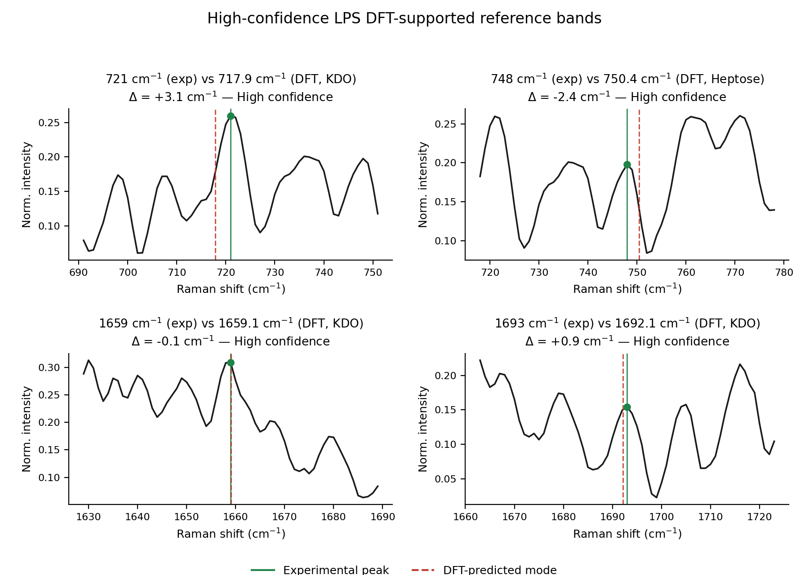
Figure 3. The four High-confidence bands, zoomed. Solid green line = experimental peak position; dashed red line = DFT-predicted position.
The 1659 cm⁻¹ band is the strongest single piece of evidence in this analysis: it is supported simultaneously by the experimental spectrum, by a KDO DFT mode (1659.1 cm⁻¹, Δ = −0.1 cm⁻¹), and independently by literature (Amide I ~1651 cm⁻¹ and a Kundu-text C=O lipid band ~1655 cm⁻¹). Three-way convergence of this kind is rare in this dataset and is the single band most defensible to lead with.

7. Literature Comparison
All literature LPS peak positions found in the project’s own documents (four partly-conflicting source documents, identified in the prior evidence audit) are compared against our experimental powder peaks and DFT-supported bands — every literature value found is shown, not only the ones that line up.
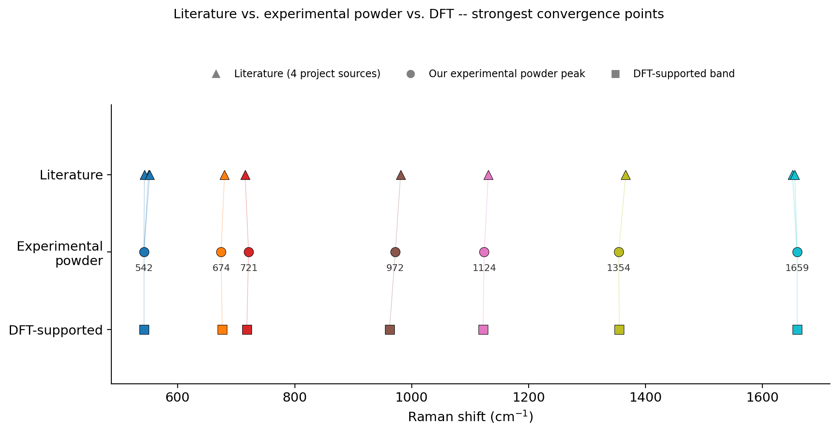
Figure 4. Literature vs. experimental powder vs. DFT for the seven strongest convergence points. Thin lines connect literature → experimental → DFT positions for the same band; short lines indicate close agreement.

Table 3. Literature → Powder → DFT Comparison (all literature peaks found in project files)
"Kundu-text" entries are flagged: a separate project document found that the paper actually attributed to Kundu et al. contains zero LPS mentions — that source’s own identity is an unresolved internal conflict in the project’s files, preserved here rather than resolved.
Literature (cm⁻¹) | Source | Assignment | Our Powder (cm⁻¹) | DFT-Supported (cm⁻¹, fragment, confidence) | Status
550 | A (Wu 2021, Enteric LPS) | beta(CH2) ring | 542 | 542 (Heptose, Moderate) | Strong (literature -> our powder -> DFT-supported)
680 | A (Wu 2021, Enteric LPS) | delta(C-O-C) fatty acid | 674 | 676 (Heptose, Moderate) | Strong (literature -> our powder -> DFT-supported)
850 | A (Wu 2021, Enteric LPS / thesis) | nu(C-O-C) saccharide / glycosidic | - | 849 (Myristic_Acid) | Literature/DFT only (theory places a mode here; no major exp peak detected)
988 | A (Wu 2021, Enteric LPS / thesis) | Carbohydrate (KDO) | - | 990 (KDO) | Literature/DFT only (theory places a mode here; no major exp peak detected)
1131 | A (Wu 2021, both LPS types) + Kundu-text | Fatty acid C-C / lipid vibrations | 1124 | 1122 (KDO, Moderate) | Strong (literature -> our powder -> DFT-supported)
1330 | A (Wu 2021, both LPS types) | Phospholipid delta(CH) | - | 1330 (KDO) | Literature/DFT only (theory places a mode here; no major exp peak detected)
1450 | A (Wu 2021, Enteric LPS) | CH3/CH2 deformation | - | 1458 (Myristic_Acid) | Literature/DFT only (theory places a mode here; no major exp peak detected)
543 | A2 (Wu 2021, N. meningitidis LPS) | Glycosidic ring | 542 | 542 (Heptose, Moderate) | Strong (literature -> our powder -> DFT-supported)
552 | A2 (Wu 2021, N. meningitidis LPS) | Lipid ring | 542 | 542 (Heptose, Moderate) | Strong (literature -> our powder -> DFT-supported)
715 | A2 (Wu 2021, N. meningitidis LPS) | C-N | 721 | 718 (KDO, High) | Strong (literature -> our powder -> DFT-supported)
733 | A2 (Wu 2021, N. meningitidis LPS) | Carbohydrate | 736 | - | Experimental/Literature only (no DFT-supported match at this exp peak)
981 | A2 (Wu 2021, N. meningitidis LPS) | Lipid beta(CH) | 972 | 962 (Heptose, Moderate) | Strong (literature -> our powder -> DFT-supported)
1066 | B (Apr-2026 lit. report) | P-O-C / C-O (~1058-1075) | - | 1066 (Glucosamine) | Literature/DFT only (theory places a mode here; no major exp peak detected)
1230 | B (Apr-2026 lit. report, PRIMARY) | P=O asym (~1220-1240) | - | 1224 (Heptose) | Literature/DFT only (theory places a mode here; no major exp peak detected)
1550 | B (Apr-2026 lit. report) | Amide II (~1540-1560) | - | - | Literature only (no match in our data)
1651 | B (Apr-2026 lit. report) | Amide I (~1645-1658) | 1659 | 1659 (KDO, High) | Strong (literature -> our powder -> DFT-supported)
1738 | B (Apr-2026 lit. report) | C=O ester (~1735-1742) | 1727 | - | Experimental/Literature only (no DFT-supported match at this exp peak)
857 | D (Yang et al. 2022 / Fig P1) | LPS band (differentiation set) | - | 858 (Glucosamine) | Literature/DFT only (theory places a mode here; no major exp peak detected)
1003 | D (Yang et al. 2022 / Fig P1) | LPS band (differentiation set) | - | 1003 (Heptose) | Literature/DFT only (theory places a mode here; no major exp peak detected)
1333 | D (Yang et al. 2022 / Fig P1) | LPS band; overlaps LTA per Fig P1 note | - | 1330 (KDO) | Literature/DFT only (theory places a mode here; no major exp peak detected)
1614 | D (Yang et al. 2022 / Fig P1) | LPS band; overlaps LTA per Fig P1 note | 1615 | - | Experimental/Literature only (no DFT-supported match at this exp peak)
1316 | Kundu-text (flagged conflicted, see note) | Aliphatic molecules | - | 1322 (Heptose) | Literature/DFT only (theory places a mode here; no major exp peak detected)
1366 | Kundu-text (flagged conflicted, see note) | Lipids | 1354 | 1355 (KDO, Moderate) | Strong (literature -> our powder -> DFT-supported)
1579 | Kundu-text (flagged conflicted, see note) | Graphitic carbon -- likely SERS-substrate artifact | 1574 | - | Experimental/Literature only (no DFT-supported match at this exp peak)
1655 | Kundu-text (flagged conflicted, see note) | Lipids (C=O) | 1659 | 1659 (KDO, High) | Strong (literature -> our powder -> DFT-supported)

8. Unmatched Experimental Bands
17 of the 43 major experimental peaks have no DFT candidate within ±15 cm⁻¹. This is labelled "no DFT match" — not an error and not evidence against the peak. These bands cluster heavily in the 1574–1998 cm⁻¹ region, consistent with the DFT composite’s near-zero predicted activity there (Figure 2); the 5-fragment model simply does not include a structural component expected to be active in that range at the modelled level of theory.
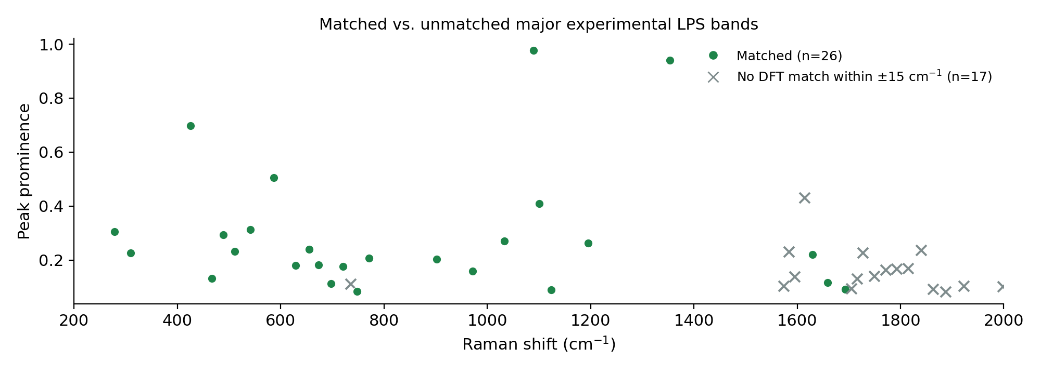
Figure 5. Matched (green circles) vs. unmatched (grey crosses) major experimental LPS bands, by Raman shift and prominence.
Experimental Raman (cm⁻¹) | Prominence | Note
736.0 | 0.1104 | No DFT match within ±15 cm⁻¹
1574.0 | 0.1022 | No DFT match within ±15 cm⁻¹
1584.0 | 0.2292 | No DFT match within ±15 cm⁻¹
1595.0 | 0.1367 | No DFT match within ±15 cm⁻¹
1615.0 | 0.4298 | No DFT match within ±15 cm⁻¹
1705.0 | 0.0924 | No DFT match within ±15 cm⁻¹
1716.0 | 0.1308 | No DFT match within ±15 cm⁻¹
1727.0 | 0.2263 | No DFT match within ±15 cm⁻¹
1750.0 | 0.1396 | No DFT match within ±15 cm⁻¹
1772.0 | 0.1617 | No DFT match within ±15 cm⁻¹
1793.0 | 0.1662 | No DFT match within ±15 cm⁻¹
1815.0 | 0.169 | No DFT match within ±15 cm⁻¹
1840.0 | 0.2366 | No DFT match within ±15 cm⁻¹
1863.0 | 0.0906 | No DFT match within ±15 cm⁻¹
1888.0 | 0.0821 | No DFT match within ±15 cm⁻¹
1923.0 | 0.1026 | No DFT match within ±15 cm⁻¹
1998.0 | 0.1003 | No DFT match within ±15 cm⁻¹

9. Current SERS Status
No LPS SERS measurement exists in the project data. This reanalysis, and the prior evidence audit, both confirm — independently, from three separate project documents — that LPS SERS has not yet been performed on the project’s own fabricated Ag/Si substrates. Only NAM and the Rhodamine-6G (R6G) validation standard have recorded SERS measurements in this project.
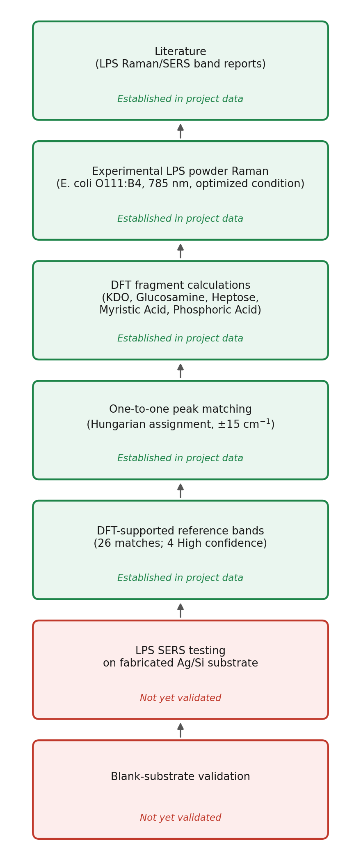
Figure 6. LPS evidence workflow. SERS testing and blank-substrate validation are marked "Not yet validated" — they do not yet exist in the project data.

10. Limitations
• The DFT model is fragment-based, not an intact-LPS calculation — it cannot represent inter-fragment coupling, and the modest whole-curve fit (R² ≈ 0.05, corrected pipeline) reflects this.
• A DFT match within ±15 cm⁻¹ does not prove molecular specificity — many matched functional groups (C–H, ring, C=O modes) occur in other biomolecules too.
• 26 of 43 major peaks are matched; the remaining 17 are not explained by this 5-fragment model, concentrated above ~1574 cm⁻¹.
• The literature comparison pools four source documents that do not fully agree with each other on peak position; agreement in Table 3/Figure 4 is reported honestly as partial, not exhaustive.
• No LPS SERS data and no LPS-specific blank-substrate control exist yet — an LPS SERS detection claim is not supportable from current project data.

11. Recommended Next Experiment
Acquire LPS SERS spectra on the project’s already-fabricated Ag/Si substrate, alongside a matched blank-substrate control (bare Si and Ag-Si with no analyte), following the four-way control design already written in the project’s own LPS SERS Experimental Design document. Prioritize looking for the 1659 cm⁻¹ band and the other three High-confidence bands as the first targets to search for in the SERS spectrum, since they are the strongest DFT-supported candidates currently available — while treating any apparent match there as a hypothesis to test, not a foregone conclusion.

12. Final Conclusion
This project has real, file-anchored evidence linking LPS powder Raman to fragment-based DFT calculations: 26 of 43 major experimental bands are matched one-to-one to a DFT-predicted mode within ±15 cm⁻¹ (MAE 3.94 cm⁻¹, RMSE 5.57 cm⁻¹), and four of those matches meet a strict High-confidence criterion. The 1659 cm⁻¹ band in particular has convergent experimental, DFT and literature support. These are appropriately called DFT-supported LPS reference bands, not validated biomarkers. What the project does not yet have is any LPS SERS measurement or LPS blank-substrate control — so a DFT → powder → SERS three-way correspondence cannot currently be claimed, and should not be presented as such until that evidence is collected.

Questions Sir May Ask
1. Why fragment-based DFT, not the whole LPS molecule?
LPS is too large and structurally heterogeneous (Lipid A + core oligosaccharide + O-antigen) to simulate intact at this level of theory in reasonable time. Five representative fragments covering its major chemical domains were calculated instead — a documented, defensible simplification, not a shortcut.
2. Why 26 matches specifically?
26 is the number of the 43 major experimental peaks that have a DFT-candidate mode within ±15 cm⁻¹ under strict one-to-one (Hungarian) assignment. It is not a chosen or rounded number — it falls out of the matching procedure applied to the actual data.
3. Why not all experimental peaks?
The remaining 17 peaks (mostly above ~1574 cm⁻¹) have no DFT candidate close enough — the 5-fragment model has little predicted activity in that region. This is reported as an open gap, not hidden or force-matched.
4. Why ±15 cm⁻¹ as the matching tolerance?
It is a documented, literature-consistent tolerance for DFT-vs-experiment Raman matching (typical acceptable error is often quoted as 5–10 cm⁻¹ for a good match, up to ~15 for a usable one) — wide enough to catch real matches, tight enough to reject coincidental ones, and applied uniformly.
5. Why are the four High-confidence bands important?
They meet the strictest criterion used here: within 5 cm⁻¹ of a DFT mode, and that mode is the only fragment candidate nearby — i.e. an unambiguous, tight match, not one of several overlapping possibilities.
6. Why is 1659 cm⁻¹ particularly important?
It is the only band with three independent lines of support at once: our experimental spectrum, a KDO DFT mode (Δ = −0.1 cm⁻¹), and literature (Amide I / C=O region). That convergence is rare in this dataset.
7. Are these LPS-specific biomarkers?
No — they are called DFT-supported LPS reference bands deliberately. A positional match to a DFT mode does not establish that the band is unique to LPS; the matched functional groups are shared with other biomolecules.
8. What does the literature comparison show?
Of 25 literature peak positions pooled from four project documents, 8 show full three-layer agreement (literature + our powder + DFT); the rest show partial support or none. The literature sources themselves do not fully agree with each other, which is reported explicitly rather than smoothed over.
9. Why are some experimental peaks unmatched?
Because the 5-fragment DFT model does not predict activity everywhere the real powder spectrum shows a peak — particularly above ~1574 cm⁻¹. This could reflect missing structural components in the fragment model, or spectral features the model was never expected to capture; it is not labelled as noise or error.
10. What is the next step for LPS SERS?
Acquire actual LPS SERS spectra on the project’s fabricated Ag/Si substrate with a proper blank-substrate control, and check whether the DFT-supported reference bands — especially 1659 cm⁻¹ — reappear. Until that is done, LPS SERS detection is not established.

